This source code is licensed, not sold, and is subject to a written license agreement. Among other things, no portion of this source code may be copied, transmitted, disclosed, displayed, distributed, translated, used as the basis for a derivative work, or used, in whole or in part, for any program or purpose other than its intended use in compliance with the license agreement as part of the QualNet software. This source code and certain of the algorithms contained within it are confidential trade secrets of Scalable Network Technologies, Inc. and may not be used as the basis for any other software, hardware, product or service.

SCENARIO PURPOSE: Small scale Layer 3 switched Ethernet networks in QualNet and EXata

SCENARIO:

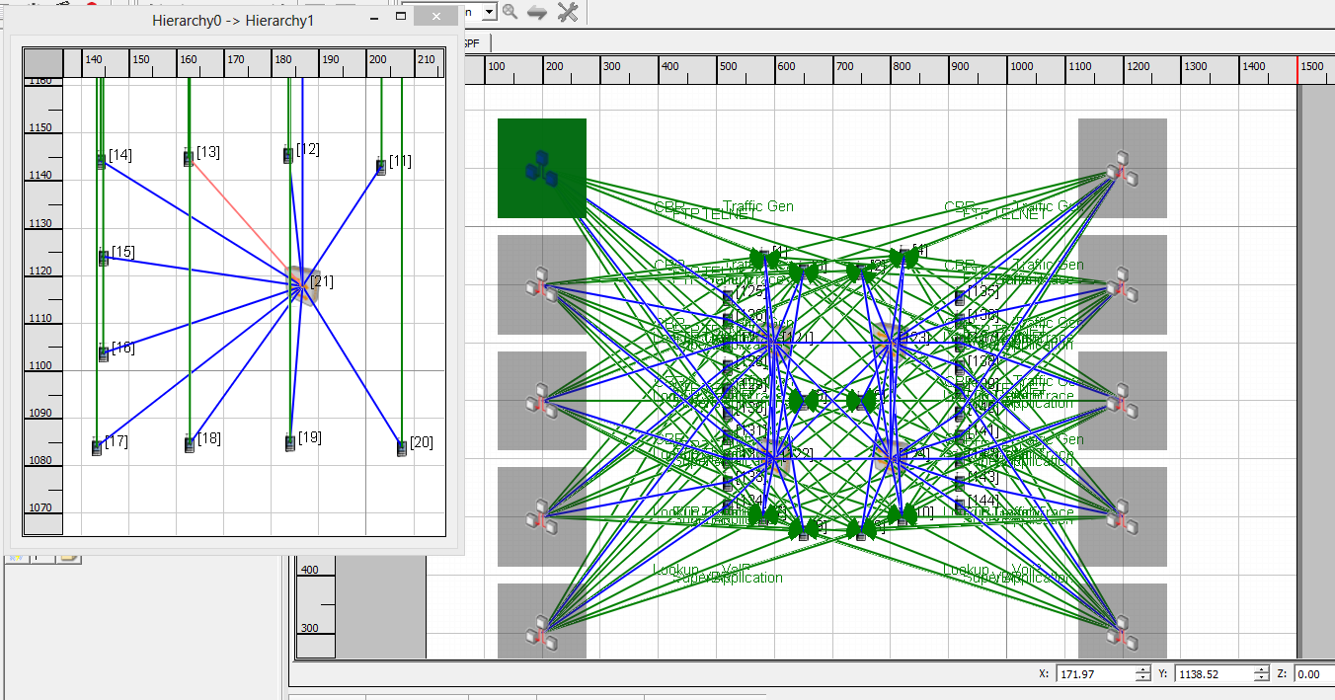

There are four Ethernet Switches that form a fully meshed wired network backbone. Each switch has a default device acting as a layer 3 switch port linked with a 1 Tbps to the switch. The default device facilitates assigning a subnet IP address to the network spooked from the switch as EXata / QualNet Ethernet Switches do not support layer 3 switching definitions. One hundred nodes are connected in groups of ten to Ethernet switches. The ten Ethernet switches are then dual homed to the core network via 100 Mbps Ethernet. The routing protocol is OSPF. Application traffic is from the end device to an “application server”.

APPLICATIONS:

CBR: Source - 11, 22, 33, 44, 55, 66, 77, 88, 99, 110; Destination - 1

FTP: Source - 12, 23, 34, 45, 56, 67, 78, 89, 100, 111; Destination - 3

FTP/GENERIC: Source – 13, 24, 35, 46, 57, 68, 79, 90, 101, 112; Destination - 5

LOOKUP: Source – 14, 25, 36, 47, 58, 69, 80, 91, 102, 113; Destination - 7

SUPER-APPLICATION: Source – 15, 26, 37, 48, 59, 70, 81, 92, 103, 114; Destination - 9

TELNET: Source – 16, 27, 38, 49, 60, 71, 93, 104, 115; Destination - 2

TRAFFIC-GEN: Source – 17, 28, 39, 50, 61, 72, 83, 94, 105, 116; Destination - 4

TRAFFIC-TRACE: Source – 18, 29, 40, 51, 62, 73, 84, 95, 106, 117; Destination - 6

VBR: Source – 19, 30, 41, 52, 63, 74, 85, 96, 107, 118; Destination - 8

VOIP: Source – 20, 31, 42, 53, 64, 75, 86, 97, 108, 119; Destination - 10

DESCRIPTION OF THE FILES:-\

1. Wired-100NodedOSPF.app - QualNet configuration file for application input.
2. Wired-100NodedOSPF.config - QualNet configuration input file.
3. Wired-100NodedOSPF.expected.stat - QualNet statistics collection.
4. Wired-100NodedOSPF.nodes - QualNet configuration file for node position.
5. Wired-100NodesOSPF.endpoint – Terminal Address File.
6. Wired-100NodesOSPF.trc – QualNet configuration file for Traffic Trace.
7. Wired-100NodesOSPF README.docx – This File source.
8. Wired-100NodesOSPF README.pdf – This file Distributable.